Enhanced Entity-Relationship Diagram:

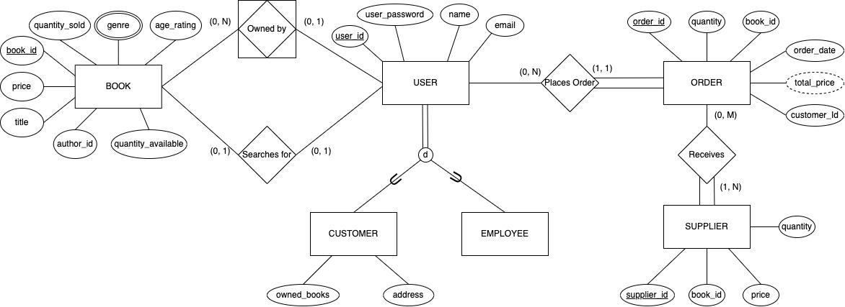

Enhanced Entity-Relationship Diagram Breakdown:

Relation | Primary/Foreign Keys | Attributes
User | Primary Key:  user_id - int (10)  - Identifying register for each user (each user type would have a specific starting sequence to differentiate between users) | user_password - varchar (20)  - Password user uses to login (along with email address)  name - varchar (30)  - Full name of the user  email - varchar (50)  - Email address user uses to login (along with user_password)  Subclasses:  Customer  - owned_books - Null String List  - List of name of books that customer has previously placed an order for  - address - varchar (100)  - Address of customer used to deliver placed orders  Employee
Order | Primary Key:  order_id - int (10)  - Identifying register for each order  Foreign Key:  customer_id - int (10)  - Identifying register for each customer  book_id - int (10)  - Identifying register for each book | quantity - int (5)  - Number of books placed in order  total_price - double (10)  - Total sum of price of books  order_date - date(MM-DD-YYYY)  - Date of which the order was placed
Supplier | Primary Key:  supplier_id - int (10)  - Identifying register for each supplier  Foreign Key:  book_id - int (10)  - Identifying register for each book | price - double (10)  - The price tag of each book  quantity - int (5)  - Number book(s) bought from the supplier
Book | Primary Key:  book_id - int (10)  - Identifying register for each book | Price - double (4)  - Cost of each book  age_rating - int (2)  - The appropriate age range for the intended audience of the book  genre - varchar (20)  - Categorizes books to assist users as they search  quantity_available - int (5)  - Tracks the number of copies available for each book  quantity _sold - int (5)  - Records the total number of copies each book sold  title - varchar (100)  - Allows users to search for the name of a book  author_id - int (10)  - Links each book to its designated author  book_id - int (10)  - Identifies each book
Owned_By | Foreign Keys:  book_id - int (10)  - Identifying register for each book  user_id - int (10)  - Identifying register for each user (each user type would have a specific starting sequence to differentiate between users)

Relational Mapping:
